**Activity based**

**Project Report on**

**Computer Networks**

**Submitted to Vishwakarma University, Pune**

**Under the Initiative of**

**Contemporary Curriculum, Pedagogy, and Practice (C2P2)**

**By**

**Arun Adhikari**

**SRN No : 202100406**

**Roll No : 38**

**Div : G**

**Third Year Engineering**

**Department of Computer Engineering**

**Faculty of Science and Technology**

**Academic Year**

**2023-2024**

**Contents**

1. **Problem Statement**
2. **Objectives**
3. **Business requirements: (Stakeholders, Data Sources, Analytical Requirements, Security Requirements, Technical Requirements, Assumptions)**
4. **Schema Design (Identify Fact table, Dimension table, Primary keys, Foreign keys)**
5. **Code for Table creation and data insertion.**
6. **Conclusion**

**Problem Statement**

**Objectives**

1. **Design and Develop a Star Schema**  
   Build a star schema structure that centralizes investment data in a fact table, linked to relevant dimension tables. This schema will allow stakeholders to easily query and analyze investment and portfolio performance.
2. **Identify Key Business Metrics for Analysis**  
   Define essential financial and performance metrics such as investment amount, return amount, percentage return, and current value. These metrics will help in evaluating the profitability of investments across various portfolios, investment types, and time periods.
3. **Implement ETL Process**  
   Develop an ETL (Extract, Transform, Load) process to pull raw data related to investments, portfolios, purchase dates, and performance metrics, transform it, and load it into the star schema for efficient analysis and reporting.
4. **Integrate Portfolio and Investment Data**  
   Combine data from different dimensions like investment types, portfolios, purchase dates, and investor details. Ensure that the fact table links to relevant dimensions to enable analysis from multiple angles, such as tracking portfolio performance over time or comparing returns based on investment types.

**Schema Design:**

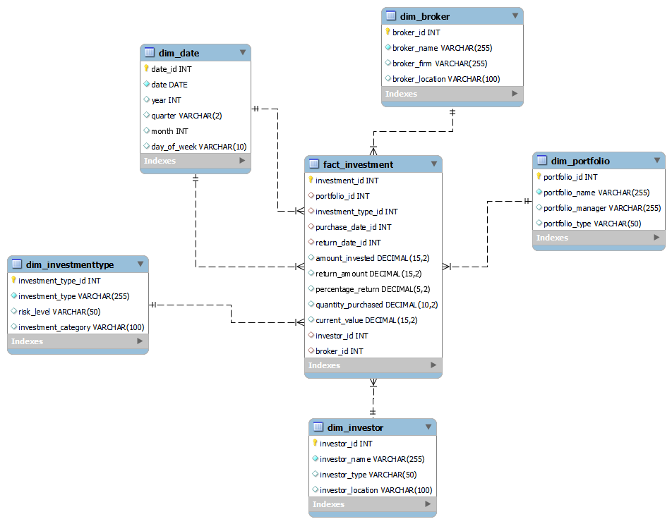

**Code:  
-- 1. Create Dim_Portfolio**

**CREATE TABLE Dim_Portfolio (**

**portfolio_id INT AUTO_INCREMENT PRIMARY KEY,**

**portfolio_name VARCHAR(255) NOT NULL,**

**portfolio_manager VARCHAR(255),**

**portfolio_type VARCHAR(50)**

**);**

**-- 2. Create Dim_InvestmentType**

**CREATE TABLE Dim_InvestmentType (**

**investment_type_id INT AUTO_INCREMENT PRIMARY KEY,**

**investment_type VARCHAR(255) NOT NULL,**

**risk_level VARCHAR(50),**

**investment_category VARCHAR(100)**

**);**

**-- 3. Create Dim_Date**

**CREATE TABLE Dim_Date (**

**date_id INT AUTO_INCREMENT PRIMARY KEY,**

**date DATE NOT NULL,**

**year INT,**

**quarter VARCHAR(2),**

**month INT,**

**day_of_week VARCHAR(10)**

**);**

**-- 4. Create Dim_Investor**

**CREATE TABLE Dim_Investor (**

**investor_id INT AUTO_INCREMENT PRIMARY KEY,**

**investor_name VARCHAR(255) NOT NULL,**

**investor_type VARCHAR(50),**

**investor_location VARCHAR(100)**

**);**

**-- 5. Create Dim_Broker**

**CREATE TABLE Dim_Broker (**

**broker_id INT AUTO_INCREMENT PRIMARY KEY,**

**broker_name VARCHAR(255) NOT NULL,**

**broker_firm VARCHAR(255),**

**broker_location VARCHAR(100)**

**);**

**-- 6. Create Fact_Investment (Fact Table)**

**CREATE TABLE Fact_Investment (**

**investment_id INT AUTO_INCREMENT PRIMARY KEY,**

**portfolio_id INT,**

**investment_type_id INT,**

**purchase_date_id INT,**

**return_date_id INT,**

**amount_invested DECIMAL(15, 2),**

**return_amount DECIMAL(15, 2),**

**percentage_return DECIMAL(5, 2),**

**quantity_purchased DECIMAL(10, 2),**

**current_value DECIMAL(15, 2),**

**investor_id INT,**

**broker_id INT,**

**-- Foreign Key Constraints**

**FOREIGN KEY (portfolio_id) REFERENCES Dim_Portfolio(portfolio_id),**

**FOREIGN KEY (investment_type_id) REFERENCES Dim_InvestmentType(investment_type_id),**

**FOREIGN KEY (purchase_date_id) REFERENCES Dim_Date(date_id),**

**FOREIGN KEY (return_date_id) REFERENCES Dim_Date(date_id),**

**FOREIGN KEY (investor_id) REFERENCES Dim_Investor(investor_id),**

**FOREIGN KEY (broker_id) REFERENCES Dim_Broker(broker_id)**

**);**

**Conclusion:**

The star schema designed for managing and analyzing investment and portfolio data provides a structured and efficient way to capture key investment metrics such as returns, portfolio performance, and investor behavior. By integrating data from various dimensions like investment types, portfolios, and time, stakeholders can gain valuable insights into financial performance, make informed decisions, and optimize investment strategies. The schema supports robust querying, ensuring that portfolio managers, investors, and executives can track and analyze data effectively to achieve business objectives.